

Programme Name: ________**BCS HONS**_______________________________________

Course Code: __**CSC 2330** _______

Course Name: ___**Software Project Management**_____ ______________________________

**Individual Project**

Date of Submission: ______**2/6/2020**_____________

**Submitted By: Submitted To:**

Student Name**: Dipesh Tha Shrestha** Faculty Name**:** **Satyam Paudel**

IUKL ID: **041902900028** Department**: LMS**

Semester**: Third Semester**

Intake**: September 2019**

**Website Development Project**

**Date:** June 14 2020

**Project Plan**: Prabhu Store

**Presented to**: Prabhu Bank limited

**Presented by:** Dipesh Tha Shrestha

**Introduction of the Organization:**

Prabhu Bank Limited is a commercial bank in Nepal. The bank is an ‘A’ class commercial bank licensed by Nepal Rastra Bank and has branches all across the nation with its head office in Kathmandu which provides entire commercial banking services.

The bank's shares are publicly traded as an 'A' category company in the Nepal Stock Exchange. It is one of the highest-earning banks in Nepal and is one of the banks having the highest number of shareholders.

The bank has been maintaining harmonious correspondent relationships with various international banks from various countries to facilitate trade, remittance, and other cross border services. Through these correspondents, the bank is able to provide services in any major currencies in the world.

Prabhu store will an online marketplace and logistics company which operates in markets of Nepal. This website will compete with website like daraz and sastodeal. Prabhu store is sponsor by prabhu bank.

**Other site owned by Prabhu Bank limited**

1. **Prabhu Pay**

PrabhuPAY App allows its users to simplify the payment process. With this App, the consumers can easily make payments for the goods purchased and services rendered. Quick recharge and easy payment of various utility bills makes this App more users friendly and on top of that consumers can also transfer the small value fund to the consumers within PrabhuPAY network.Time is the most valuable thing in 21st century. Every second of our life is ticking and we have so much to achieve in our Lives. So why waste time on Queues of Bill payments and Banking queues just make your all payments from One app that is “PRABHUPAY Wallet”. No need to worry about the long queue for your basic services of Household bills like (Electricity, Water, Internet, Landline, Television) payments. These can be easily paid through your Digital Wallet “PrabhuPAY”

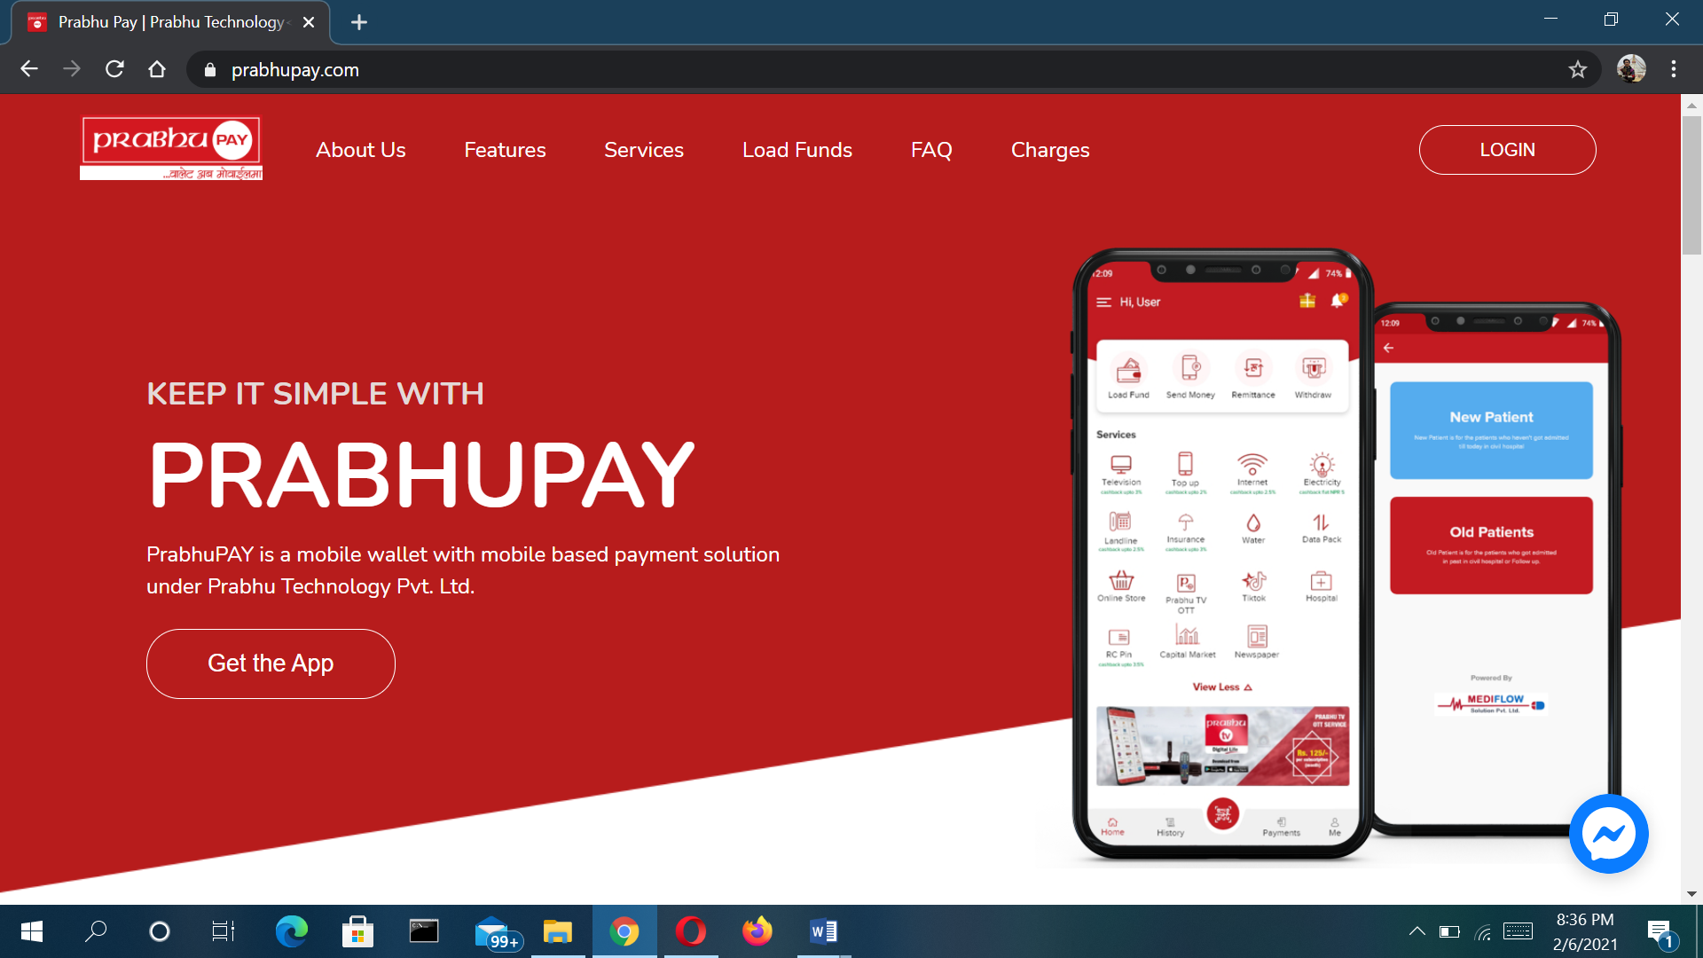

1. **Prabhu TV**

PRABHU TV – call sign is licensed by the government of Nepal and promoted by Prabhu Group to operate the 2nd generation Digital Video Broadcasting (DVB-T2) in Nepal. its network will have a nationwide footprint and will deliver high quality 24/7 wireless digital TV service to consumers 365 days a year.

DVB T2 wireless platform will distribute digital signals from PRABHU TV broadcast stations and international TV channels to TV viewers across the country. With the purchase of one of Prabhu TV's authorized set top boxes and a simple antenna, TV viewers will have access to all local broadcast TV outlets. Additionally, an array of International TV channels (both SD and HD) and specialty programs will be accessible for a minimal fee.

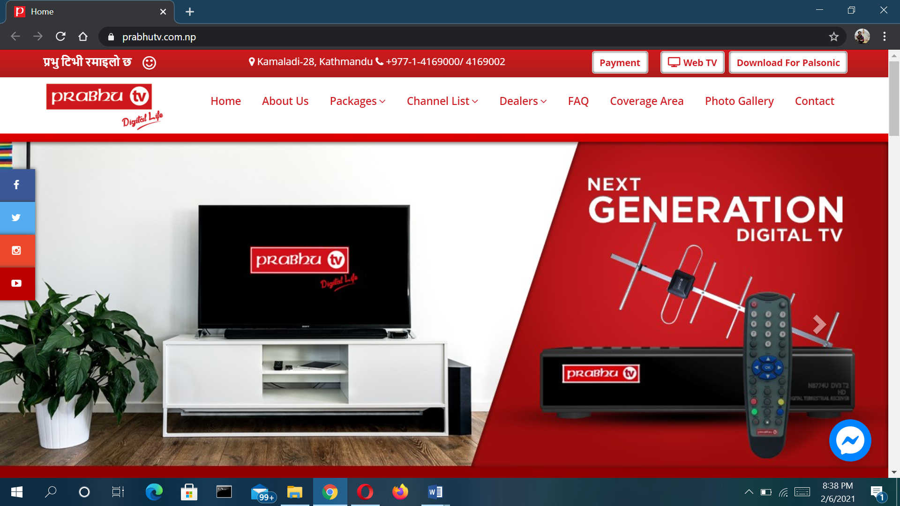

**Project Charter and Scope statement**

|  |  |
| --- | --- |
| **Project Title** | **Prabhu Store** |
| Project Manager | Dipesh Tha Shrestha  Dipeshthashrestha@gmail.com |
| Date of Authentication | June 14 2020 |
| Project start Date | June 15 2020 |
| Project Deadline | September 20 2020 |
| Goals | * Selling a service or product. * Providing product support or customer service. * Providing corporate information. * **create a differentiated customer experience to capture market share**. |
| Scope | * Determining main goals. * Determining website flow. * Target Market Reserch |
| objective | * To significantly improve trade and commerce in Nepal. * To put Nepal on the global digital/electronic market. |
|  |  |

**Role and Responsibilities**

|  |  |  |
| --- | --- | --- |
| **Name** | **Postion** | **Role** |
| **Prabhu Bank Limited** | **Sponsor** | **Sponsor** |
| Dipesh Tha Shrestha | Project Manager | Team Member |
| Ram Shrestha | Personal Assistant | Team Member |
| Jay Thapa | Data Analysts | Team Member |
| Anajan Kc | Planning Officers | Team Member |
| Laxmi Shrestha | Finance Officer | Team Member |
| Anjal  Shyam  Dev | IT Team | Team Member |

**Project communication Plan**

A project communication plan is a simple tool that enables you to communicate

effectively on a project with your client, team, and other stakeholders. It sets clear

guidelines for how information will be shared, as well as who’s responsible for and

needs to be looped in on each project communication. As the project manager you

have to map out every task and deliverable to get you across the finish line. Is

should be done same for project communications. After all, the project plan needs

a steady stream of communication to stay on track**.**

**Site advantage:**

* Save Time
* Save Fuel
* Save Energy
* Comparison of Prices
* 24/7 Availability
* Hate Waiting in Lines
* Too Ashamed to Buy
* Easy to Search Merchandise You Want to Buy

**Budget**

The table below presents the budget for the project. The WBS001 and WBS002 shall be renewed annually.

|  |  |  |
| --- | --- | --- |
| **Identifier** | **Work Package** | **Cost ($)** |
| WBS001 | Software | 500.32 |
| WBS002 | Software | 3116.57 |
| WBS003 | Software | 1007.85 |
| WBS004 | Software | 209.66 |
| WBS005 | Software and Hardware | 4588.19 |
| **TOTAL** |  | 9422.59 |

**Site Uses:**

People uses this site or website for

* Faster buying process.
* Store and product listing creation.
* Cost reduction.
* Affordable advertising and marketing.
* Flexibility for customers.
* No reach limitations.
* Product and price comparison.
* Faster response to buyer/market demands.

**Site features:**

* Long scrolling webpages
* Video content will overtake written content
* Design with data
* Local search will get more local
* Focus on responsive
* Search engine optimization

**Work breakdown structure.**

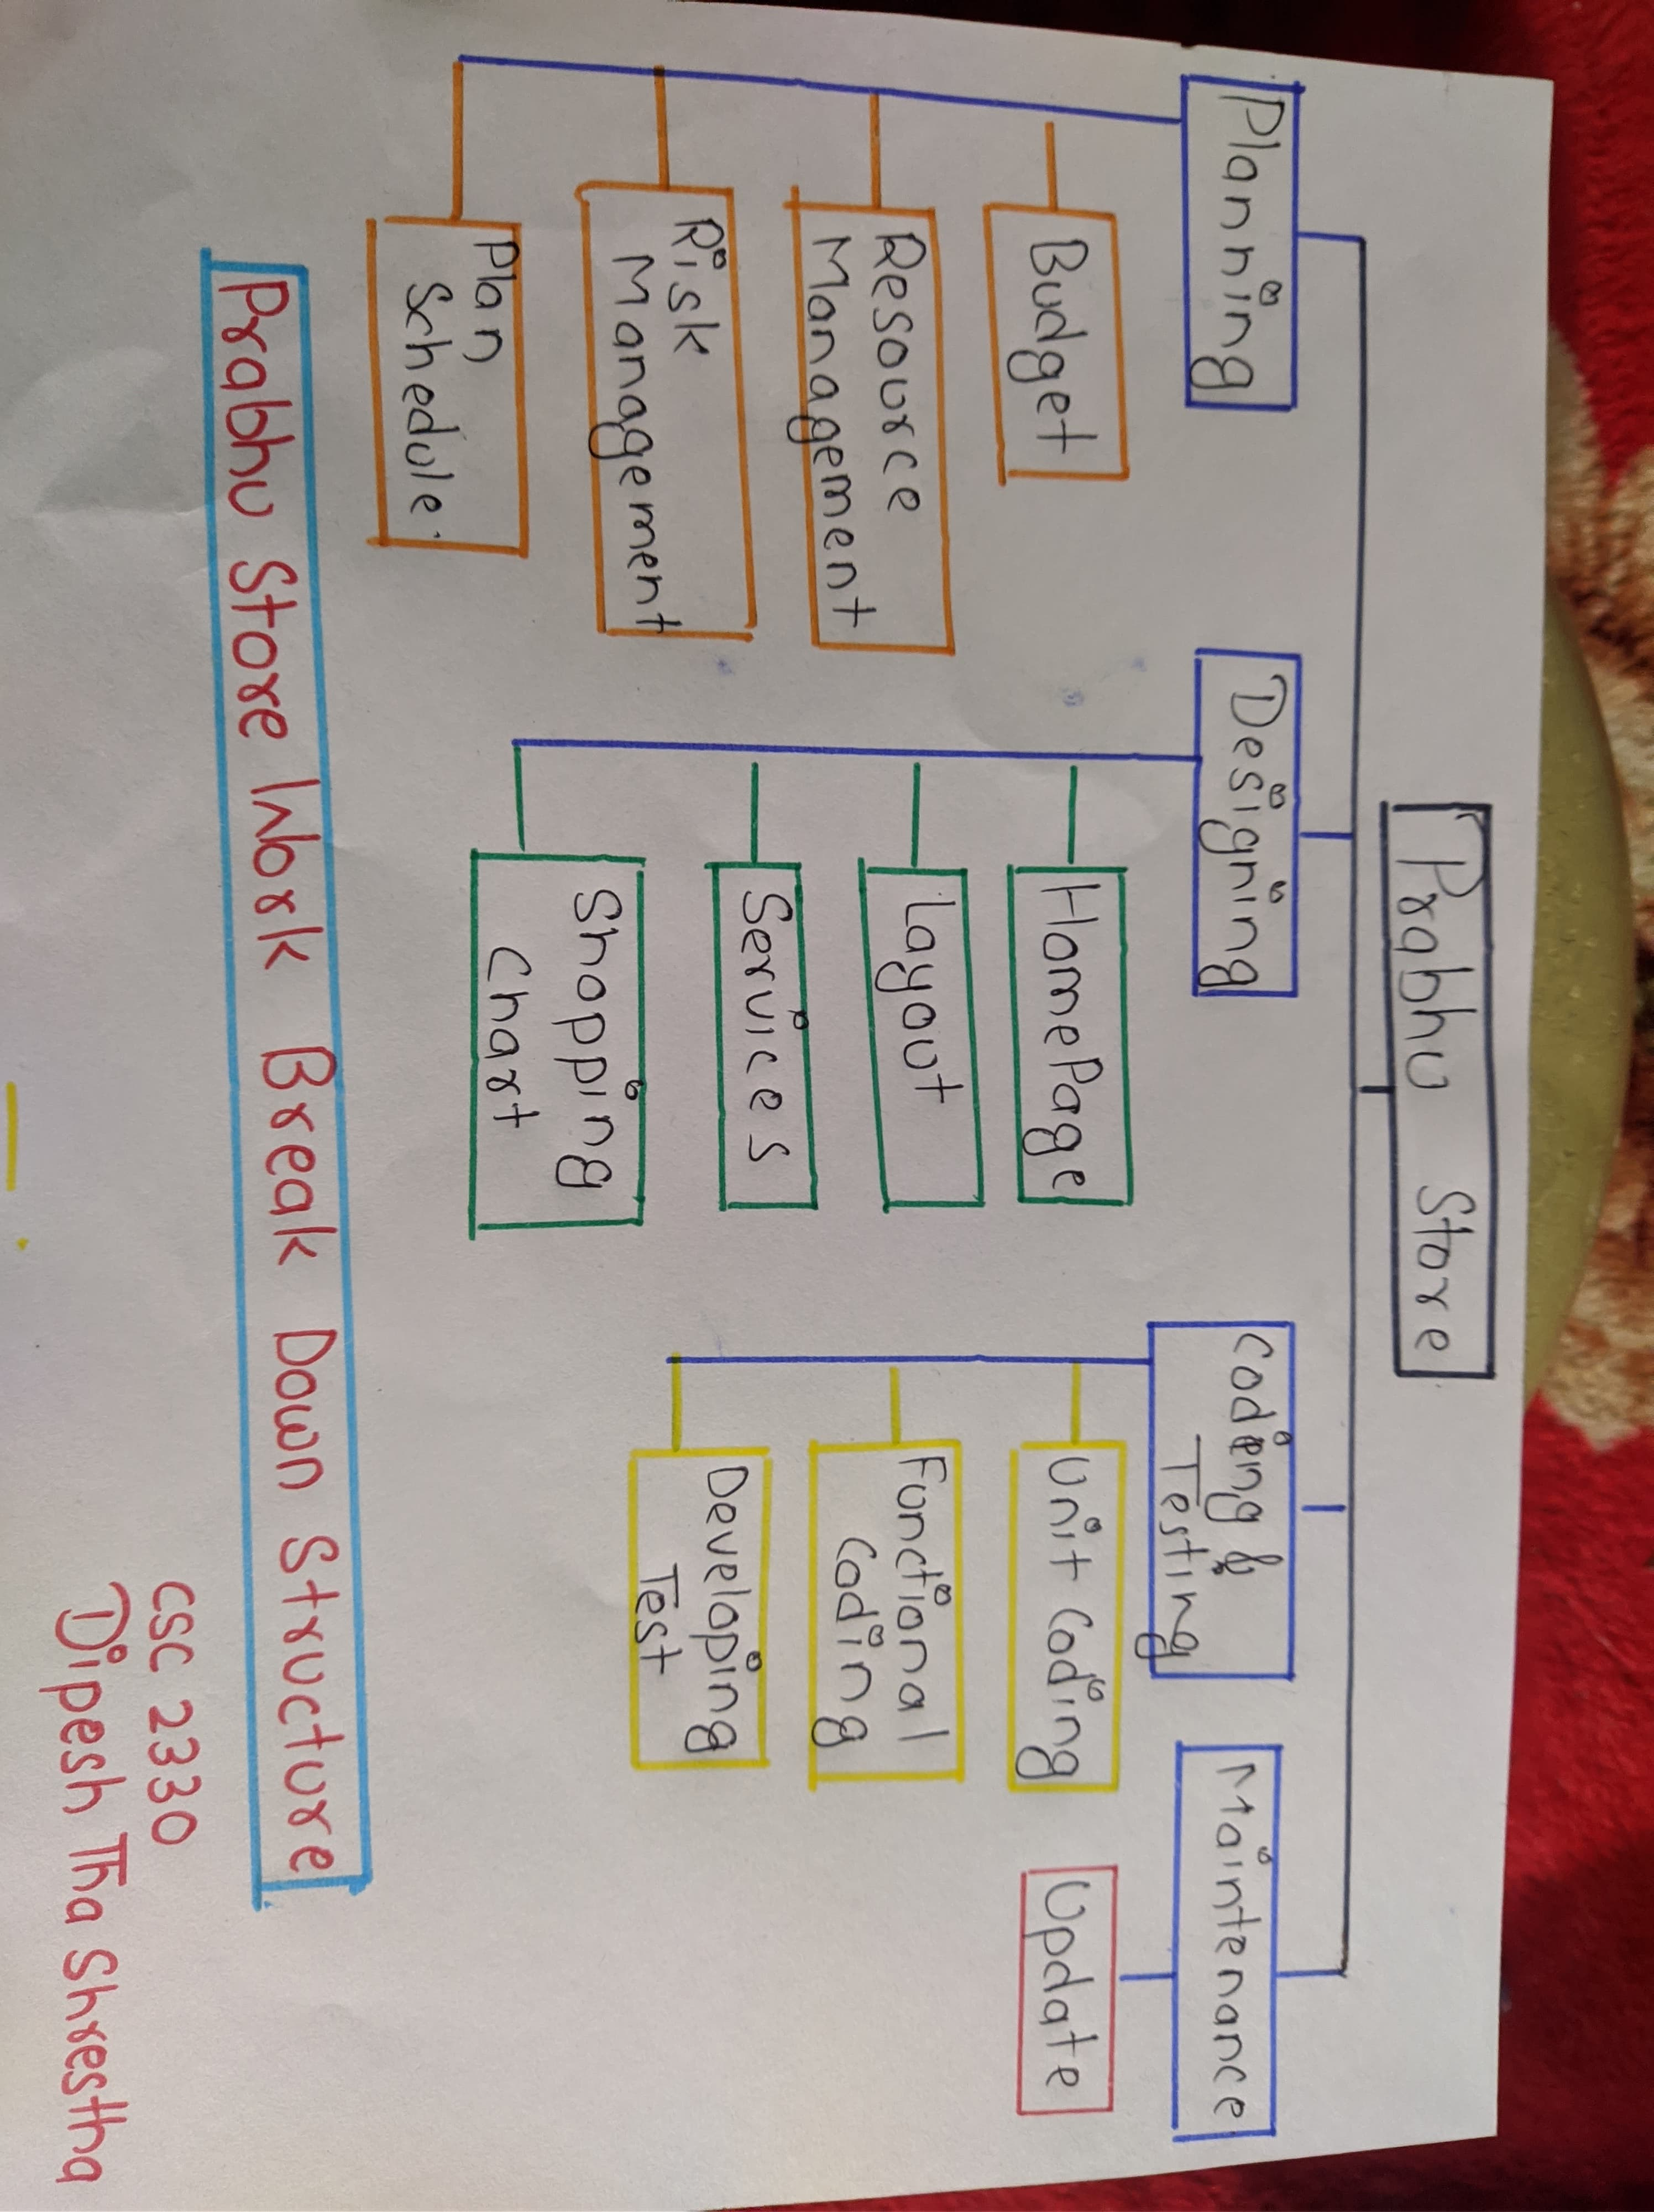

**Gantt Chart for Prabhu Store Website**

**Network Diagram**

|  |  |  |
| --- | --- | --- |
| **Activities** | **Procedure** | **Duration(days)** |
| Information Gathering(A) | - | 7 |
| Planning (B) | A | 14 |
| Designing (C) | B | 14 |
| Content and Writing Assembly (D) | C | 14 |
| Coding (E) | D | 21 |
| Testing , Review and launch (F) | E | 21 |

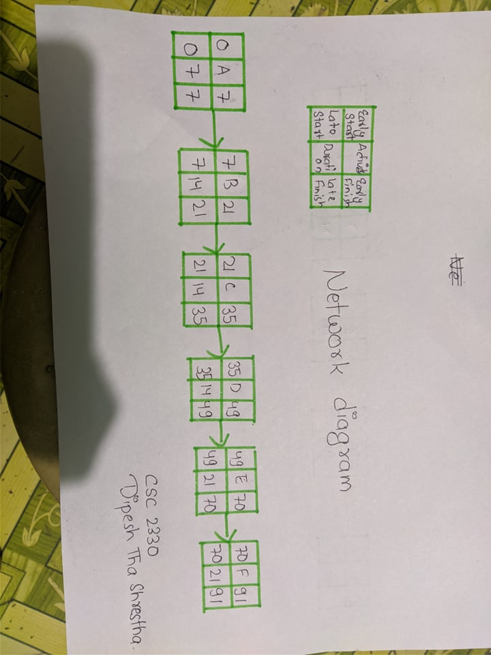

**Risk Management Plan**

This section presents the risk on the proposed project. By risk, the project team means any condition or an event that might affect the project negatively or positively should it occur. Specifically, a potential risk identification and a risk treatment plan for the proposed project were discussed.